 BartholoMewsings 

St. Bartholomew’s Episcopal Church, P.O. Box 906, High Springs, Fl 32655

<http://www.stbartshighsprings.org/> [www.facebook.com/stbartshighsprings](http://www.facebook.com/stbartshighsprings)



December 2022 Vol. XIII, Issue 12

# The True Meaning of the Advent SeasonAdvent

The first season of the church year, beginning with the fourth Sunday before Christmas and continuing through the day before Christmas. The name is derived from a Latin word for “coming.” The season is a time of preparation and expectation for the coming celebration of our Lord's nativity, and for the final coming of Christ “in power and glory.” *

# Christmas, or Christ’s Mass

Christmas (in old English, Cristes maesse) is a festival celebrated on Dec. 25, commemorating the Incarnation of the Word of God in the birth of Jesus Christ. In the BCP it is also called The Nativity of Our Lord Jesus Christ. In the United States it is also a popular secular holiday. According to the Philocalian calendar, Christmas was

first celebrated in Rome in the year 336. It gradually spread to the churches of the east, which already had a festival on Jan. 6 commemorating the manifestation of God in both the birth and baptism of Jesus. The date, Dec. 25, rests on no historical foundation. It was probably chosen to oppose the feast Natalis Solis Invicti, the birthday of the "Unconquerable Sun God" (Saturn), which took place at the winter solstice to celebrate the birth of "the Sun of Righteousness."

The customs associated with Christmas have developed from many sources. From early days the popular observance of Christmas was marked by the joy and celebration characteristic of the Roman Saturnalia and the pagan festivals which it replaced. It came to include the decoration of houses with greenery and the giving of gifts to children and the poor. In Britain other observances were added including the Yule log and Yule cakes, fir trees, gifts, and greetings. Fires and lights (symbols of warmth and lasting life) and evergreens (symbols of survival) were traditionally associated with both pagan and Christian festivals. Their use developed considerably in England with the importation of German customs and through the influence of the writings of Charles Dickens

In the BCP, Christmas Day is one of the seven principal feasts. The Christmas season lasts twelve days, from Christmas Day until Jan. 5, the day before the Epiphany. The season includes Christmas Day, the First Sunday after Christmas Day, the Holy Name of Our Lord Jesus Christ, and may include the Second Sunday after Christmas Day. In many parishes, the main liturgical celebrations of Christmas take place on Christmas Eve. *

*Source: An Episcopal Dictionary of the Church



**Editor’s Note** We hope you are enjoying the Newsletter and we welcome your comments and suggestions.

**Deadline for the next issue is** **December 21, 2022.**

Contact: Annette Jones - (386) 454-8585 or **pgrscoot97@aol.com**

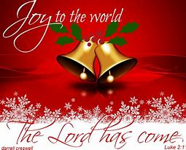 

Mew-sings from the Senior Warden……Carol Griffin

386-497-2292

St. Bartholomew’s continues to prosper despite the challenges we have faced. Our family base is strong, and we continue to add new members. This is encouraging with so many churches seeing a decline in membership. While we would all love to see more children participating in the Sunday School curriculum, it has been encouraging to see some of our younger members with their new families returning to worship with us on Sundays. We have continued work on preserving the Sanctuary this year. January will bring the painters to give a face lift to this historic gem, repair the windows, installation of a fence around our Memorial Garden and a visit from our IX Bishop of the Diocese of Florida, Bishop Coadjutor Elect Rev. Charlie Holt on Sunday, January 8th.

The election was a difficult (and long) process this year and has caused much dissension within the Diocese. We need to pray that we can look past our differences and unite in our love of the values and beliefs we share in the Episcopal Church.

I love this church, the only other church that can compare with St. Bart’s for me is St. Mary’s, Mohegan Lake, NY. While we celebrated our 125th anniversary last year, they celebrated their 250th. I attended that church from age 10 until Fr. Germeck officiated at my wedding and sent me on my way. He was a man very much like Fr. Lance, loving and nurturing. He was an integral part of my religious upbringing along with the Sisters of The Community of St. Mary’s in Peekskill, NY who put up with my shenanigans and rebellious ways during my High School years and continue to be an anchor in my spiritual life.

I find great solace in the service of The Episcopal church; it is prayerful, with readings from scripture and provides me with comfort in knowing I am speaking the same words that my family and generations of other Episcopalians for hundreds of years have spoken in worship.  A majority of the Book of Common Prayer comes directly from the Bible, and it has been said that Episcopalians read more Holy Scripture in Sunday worship than almost any other denomination in Christianity. I can go into any Episcopal church and feel connected.

While we are confronting the current issues within The Church, we cannot let our differences drive us apart but rather let our commonalities join us together in love and unity raising our voices in song during this season of wonder, joy, and hope:

“O Hail, Lord, we greet thee, born this happy morning.  
Jesus, to thee be glory given.  
Word of the Father, now in flesh appearing.  
O come, let us adore Him,

O come, let us adore Him,

O come, let us adore Him,  
Christ the Lord.” (***O COME ALL YE FAITHFUL*)**

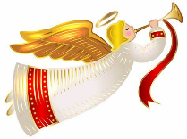As in previous December BartholoMewsings, I am including the following personal “Godwink” after the loss of my mother, Jane, in 2015. Opening an email that Christmas day in 2015 which included the following, brought tears and joy to my heart. I am including it again this year with the hope that it will bring solace

for each of you who are missing your loved ones this Christmas. They are all still with us, but greatly missed.

**In remembrance of Jimmy who will be celebrating his first Christmas in Heaven with all the other saints of our special church that have gone before.**

**Christmas in Heaven**

Dr. Albert Simpson Reitz

I've had my first Christmas in Heaven

A Glorious, wonderful day.

I stood with the saints of the ages,

who found Christ the Truth and the Way.

I sang with the Heavenly Choir:

Just think, I who longed so to sing!

And oh, what celestial music

we brought to our Savior and King!

We sang the glad songs of redemption,

How Jesus to Bethlehem came,

And how they called His name Jesus,

That all might be saved through His name.

We sang once again with the angels,

The song that they sang that blest morn,

When shepherds first heard the glad story

That Jesus, the Savior, was born.

Oh, how I wish you had been there:

No Christmas on earth could compare

With all the rapture and glory

We witnessed in Heaven so fair.

You know how I always loved Christmas;

It seemed such a wonderful day,

with all of my loved ones around me

The children so happy and gay.

Yes, now I can see why I loved it:

And oh, what a joy it will be

When you and my loved ones are with me:

 To share in the glories I see.

So dear ones on earth, here's my greeting:

Look up 'til the day dawn appears,

And oh, what a Christmas awaits us,

Beyond all our parting and tears.

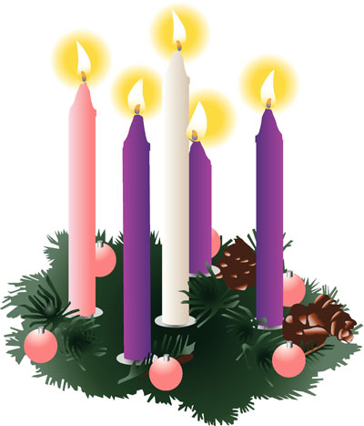**Advent Wreath**

## What the Advent Candles Symbolize

The Candles symbolize that Jesus is the Light of the World.

There are four candles, one for each Sunday leading to Christmas and a fifth candle for Christmas day. The four Sunday candles are usually tapers. There are variations in the coloring of the candles, often there are three purple and one pink candle. Occasionally, all of the candles are purple. The central candle is usually a large white pillar candle.

The purple represents repentance. The pink symbolizes joy. The central candle is called the Christ candle and is not lit until Christmas day. When you light the candle it is customary to read a few verses of scripture that relate to the meaning of the candle.

**The First Candle (The Candle of Prophecy/Hope)**

The first candle is sometimes called the candle of prophecy because it symbolizes the promises the prophets delivered as messages from God; promises that foretold Christ’s birth. Others consider the candle to be a symbol of the hope we have in Christ and so it is called the Hope candle.

**The Second Candle (The Candle of the Way)**

The second candle shows that Christ is the Way. Christians are lost in sin and Christ is the Light sent into the world to show them the way out of darkness.

**The Third Candle (The Candle of Joy)**

The third candle indicates that the only lasting Joy to be found in life on earth is through Christ. All other joy is fleeting and does not last.

**The Fourth Candle (The Candle of Peace)**

The fourth candle reminds that Jesus comes to bring Peace to both the world and to people’s hearts. Without Christ there is no peace in this world.

**The Fifth Candle (The Christ Candle or Christmas Candle)**

The fifth candle represents Christ himself who is born to save people from their sins. It is a celebration of the fulfillment of prophecy as represented in Christ’s birth and hope in the final fulfillment when Christ comes again, and Christians join him.

**\*\*\*\*\*\*\*\*\*\*\*\*\*\*\*\*\*\*\*\*\*\*\*\*\*\*\*\*\*\*\*\*\*\*\*\*\*\*\*\*\*\*\*\*\*\*\*\*\*\*\*\*\*\*\*\*\*\*\*\*\*\*\*\*\*\*\*\*\*\*\*\*\*\*\*\*\*\*\*\*\*\*\*\*\*\*\*\*\*\*\*\*\*\*\*\*\*\*\*\*\*\*\*\*\*\*\*\*\*\*\*\*\*\*\*\*\***

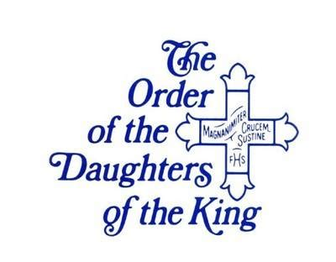The Mission of DOK order is the extension of Christ's Kingdom through Prayer, Service and Evangelism.

As we enter the Advent season, the daughters are giving!  We just completed the Thanksgiving Food drive for our area -- with the tremendous help of all St. Bart's family -- and remembering that Rosina Dennis began this several years ago.

Four pictures of St. Bart's church, deed and interior have been framed -- a gift from the Daughters to St. Bart's and also the Train Museum, to be displayed in the museum over the pew on loan from our church.

December, in keeping with our giving, DOK is contributing $100. to the worthwhile Toy Drive conducted by the High Springs Police Dept for our area children in need.

Our DOK Chapter is contributing $200. to four DOK funds: Self-denial, Master's, Endowment, and the Alpha fund, and the treasury of our Diocese, Camp Weed, will be sent $300.

We want to give thanks to Cherie Harris for serving as our chaplain with very inspirational devotions at our meetings.

DOK welcomes all the women at St. Bart's to attend our meetings and to consider joining the Daughters. Speaking of which, the next meeting is Sat. December 3rd.

We wish you a blessed Advent and Merry Christmas!

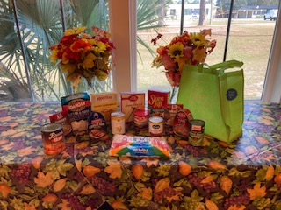

FHS

Ruthann

Sample “basket”contents

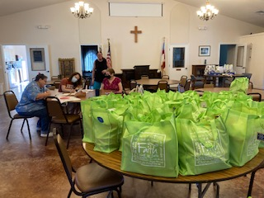 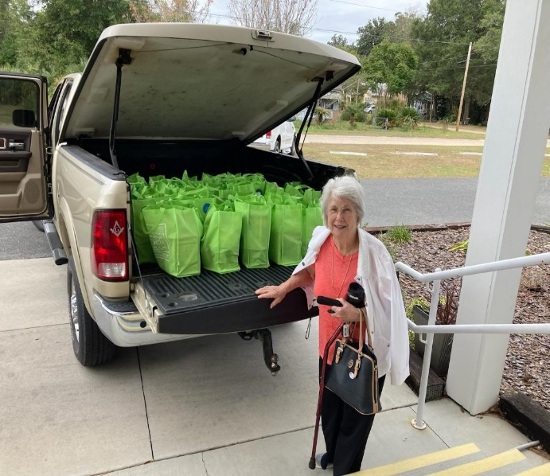

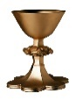**Chalice Bearers -December Lay Readers –December**

**12/4 – Neil 12/4 – Alex Matisco**

**12/11 – Gregg 12/11 – Sam Tift**

**12/18 – Annette 12/18 – Cherie Harris**

**12/24 – Neil 12/24 – Annette & Charles Jones**

**Alex Matisco**

**12/25 – NO CHURCH SERVICE**

**\*\*\*\*\*\*\*\*\*\*\*\*\*\*\*\*\*\*\*\*\*\*\*\*\*\*\*\*\*\*\*\*\*\*\*\*\*\*\*\*\*\*\*\*\*\*\*\*\*\*\*\*\*\*\*\*\*\*\*\*\*\*\*\*\*\*\*\*\*\*\*\*\*\*\*\*\*\*\*\*\*\*\*\*\*\*\*\*\*\*\*\*\*\*\*\*\*\*\*\*\*\*\*\*\*\*\*\*\*\*\*\*\*\*\*\*\***

** December Birthdays Anniversaries in December **

Dec 4 – Stephen J. Lewis 22 – Danielle Marston 20 – Susan & David Hansen

8 – Charlotte Cornell **25 – Jesus**

10 – Zemira Young 26 – Chris Hansen

12 – Anne Lundy

17 – Cindy Hinote

**Congratulations to Each of YOU! If your name does not appear here, please contact your Editor to have it added for next time.**

**Church Business:**

Advent is the start of our new year which means it is time to start working on our 2023 budget.  In order to accomplish this, our Treasurer needs to have an idea of the income for the coming year.  **Stewardship forms** **will be placed in the Church as well as the Parish Hall** **along with your envelopes for 2023**.  If you do not have a box assigned to you, please speak with Neil.

**We ask that you complete and return you 2023 Stewardship Form by the last Sunday in December.**  Your generosity is what keeps St. Bart’s growing and enables us to serve the community For His Sake.

“*All things come of Thee, O Lord, and of Thine own have we given Thee.” 1 Chronicles 29:14 (KJV).*

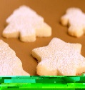 Hostess List for December 

Dec – Annette J/ Diana C Dec 11 – Bev J/Sharon & Gregg P

Dec 18 – Cookie Swap (See enclosed flyer for Details

**Note: If you would like to volunteer to bring a light snack and drink for after one 10 AM Church Service, please contact Nancy Brewer 386-496-3445**

# 

# YOU ARE INVITED

TO PARTICIPATE IN A

CHRISTMAS COOKIE SWAP

December18

at

ST. BART’S AFTER MASS

Get your Christmas baking done!

Bake one kind of cookie

Four dozen required

Bring a take home container

RSVP/ASAP

ndorbrewyahoo.com or 352 262-1320

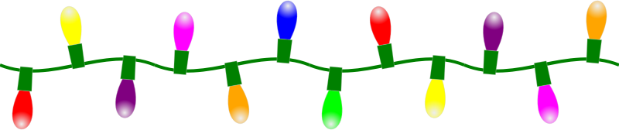

# Parament Sets (Altar Linens) We are blessed to have new Parament sets for all the seasons of the church year and following you will see pictures of the two we have used so far: *Thanks to Susan Boyle and Jane Woodward for the pictures.*

**Green for Pentecost**

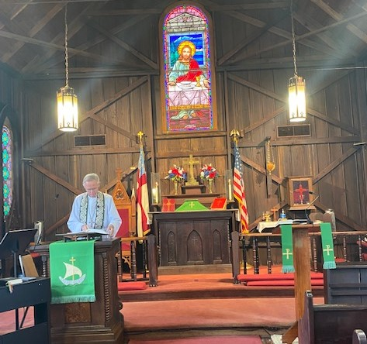

**White for Special Occasions**

**\*\*\*\*\*\*\*\*\*\*\*\*\*\*\*\*\*\*\*\*\*\*\*\*\*\*\*\*\*\*\*\*\*\*\*\*\*\*\*\*\*\*\*\*\*\*\*\*\*\*\*\*\*\*\*\*\*\*\*\*\*\*\*\*\*\*\*\*\*\*\*\*\*\*\*\*\*\*\*\*\*\*\*\*\*\*\*\*\*\*\*\*\*\*\*\*\*\*\*\*\*\*\*\*\*\*\*\*\*\*\*\*\*\*\*\*\*\*\*\***



Sunday School Teaching Schedule

For 10am Services

Dec. 4th :Diana & Diane Dec. 11th: Ruthann & Becky

Dec. 18th: Pete & Jane

Dec. 25th: Merry Christmas – No Sunday School

 **Lessons for December** 

**December 4th:** Isaiah 11:1-10; Psalm 72:1-7,18-19; Romans 15:4-13; Matthew 3:1-12

**11th:** Isaiah 35:1-10; Psalm 146:4-9; James 5:7-10; Matthew 11:2-11

**18th:** Isaiah 7:10-16; Psalm 80:1-7,16-18; Romans 1:1-7; Matthew 1:18-25

**24th:** Isaiah 9:2-7; Psalm 96; Titus 2:11-14; Luke 2:1-14,(15-20)

**25th: No Service**



**Christmas Flowers for the Altar -- Deadline December 20th**

**Wouldn’t you like to see our church decorated with beautiful poinsettias during Christmas? If you would like to provide one or more plants to be used in this way, please fill out one of the Poinsettia Order Forms available in this newsletter and also in the Parish Hall, and turn it in or mail it, along with your check or cash. Your poinsettias will be ordered as soon after the first of December as they become available. (Your plants can be taken home after Christmas.)**

- - - - - - - - - - - - - - - - - - - - - - - - - - - - - - - - - - - - - - - - - - - - - - - - - - - - - - - - - - - - - - - - - - - - - - -



**St. Bartholomew’s Episcopal Church**

**Poinsettia Order Form**

Name_______________________________________________

Telephone number____________________________________

Number of **poinsettia plants** ordered at a cost of **$10.00**

each___________________. **Check or cash** **must accompany order.** Make checks payable to “St. Bartholomew’s and put “poinsettia” in memo line.

Turn completed form in to church office or mail to:

PO Box 906

High Springs, FL 32655

Is your plant in honor ?_________ or in memory ?___________

Name of loved one____________________________________

Thank you for your order. These poinsettia plants will be used to beautify our sanctuary during the Christmas Holiday. You may take them home after Christmas.