  BartholoMewsings 

St. Bartholomew’s Episcopal Church, P.O. Box 906, High Springs, Fl 32655

<http://www.stbartshighsprings.org/> [www.facebook.com/stbartshighsprings](http://www.facebook.com/stbartshighsprings)

January 2024 Vol. XV, Issue 1

# I just had an epiphany! – FORWARD IN CHRIST ***O Come let us adore Him…***

# **The Season of Epiphany**

Taken from the An Episcopal Dictionary of the Church

A season of four to nine weeks, from the Feast of the Epiphany (Jan. 6) through the Tuesday before Ash Wednesday. The length of the season varies according to the date of Easter. The gospel stories of this season describe various events that manifest the divinity of Jesus. The coming of the Magi is celebrated on the Epiphany. The Baptism of our Lord is observed on the Sunday after Epiphany. The gospels for the other Sundays of the Epiphany season describe the wedding at Cana, the calling of the disciples, and various miracles and teachings of Jesus. The Last Sunday after the Epiphany is always devoted to the Transfiguration. Jesus' identity as the Son of God is dramatically revealed in the Transfiguration gospel, as well as the gospel of the baptism of Christ. We are called to respond to Christ in faith through the showings of his divinity recorded in the gospels of the Epiphany season.

**\*+*+*+*+*+*+*+*+*+*+*+*+*+*+*+*+*+*+*+*+*+*+*+*+*+*+*+*+*+*+*+*+*+*+*+*+*+*+*+*+*+*+*+*+*+*+*+*+*+*+*+*+*+*+\***

**Editor’s Note**

We hope you are enjoying the Newsletter, and we welcome your comments and suggestions.

**Deadline for next issue is** **January 21, 2024,** in order to give time for review.

Contact: Annette Jones - (386) 454-8585 [pgrscoot97@aol.com](mailto:pgrscoot97@aol.com)

**This month we have included Bible verses about serving others.**

**"Each of you should use whatever gift you have received to serve others, as faithful stewards of God's grace in its various forms. Do not be slothful in zeal, be fervent in spirit, serve the Lord."**  [*1 Peter 4:10-11*](https://www.biblestudytools.com/1-peter/passage/?q=1%20peter+4:10-11)

**\*+*+*+*+*+*+*+*+*+*+*+*+*+*+*+*+*+*+*+*+*+*+*+*+*+*+*+*+*+*+*+*+*+*+*+*+*+*+*+*+*+*+*+*+*+*+*+*+*+*+*+*+*+*+\***

rom our Senior Warden... *Carol Griffin 386-497-2292*

Christmas has come and gone and I pray you all had a wonderful day with friends and family. As many of you know, my brother and his wife were with us this Christmas. As we waited for Christmas Eve service to start, he mentioned to me how nice the church and grounds looked. I told him of a few of things that we had done this past year. But it got me to thinking of all the “projects” and work that have been completed in 2023. How soon we can forget what we have accomplished or take it for granted. We have been a very busy (and active) church. We painted the Church, installed protection for the stain glass windows, replaced the ramp leading into the Church, made repairs to the sound system and A/C in the Church, installed new locks on all the doors (Parish Hall and Church), installed a fence around the Memorial Garden, removed additional trees and completed the Veterans Memorial Board honoring our members that have served and protected this country and each of us.

Additionally, we have impacted the community of High Springs by participating in Pioneer Weekend and the Fall City-wide Yard sale. Our yard sales have seen many repeat customers over the years due to the variety, quality, and great deals. Of course, we are known for our “Vidalia Onions”. We continued our traditions of providing Thanksgiving food “baskets” for those in need in High Springs as well as providing personalized cards, cookies, and assorted tokens of appreciation to the residents of the two assisted living facilities in High Springs as well as the one in Fort White at Easter and Christmas. But, the big event this year was the Train Event. For a first try, it was a great success. The joy on the faces of the children and many of the adults made it a success and an event that should be continued. While the turn-out could have been better, the weather did not cooperate, with severe weather warnings one day. This event involved many of the members of the church and I think we had just as much fun as our guests. I thank all of you that enthusiastically volunteer your time and talent to these events. “The deeds you do may be the only sermon some persons will hear today”. St. Francis Of Assisi

We have had over 27 visitors to St. Bart’s this past year with 6 new members and several that do not live in the area but have relatives here and consider St. Bart’s their “home” church when they are in town. St. Bart’s is a most welcoming church and that is due to each of you. Who can forget the 4 young ladies from Ft. Lauderdale who were on a “girls’ weekend”, asked to see the inside of the church, left, and then decided to stay for the service and fellowship afterwards. We had a wedding, memorial services, baptisms, confirmations, and installation of new DOK members.

In the place of this month’s “Godwink”, I am including an article by Regina Brett, of The Plain Dealer, Cleveland , Ohio.

"To celebrate growing older, I once wrote the 45 lessons life taught me. It is the most-requested column I've ever written.”

(She was 90 years old when she reprinted it.)

***In reading them I thought there were some pretty good New Year’s Resolutions to consider.***

**45 lessons life taught me:**

1. Life isn't fair, but it's still good.  2. When in doubt, just take the next

small step.  
  
3. Life is too short to waste time hating anyone... 4. Your job won't take care of you when

you are sick.  Your friends and parents

    will. Stay in touch.  
  
5.  Pay off your credit cards every month. 6. You don't have to win every

argument.  Agree to disagree.

7.  Cry with someone. It's more healing than crying alone. 8. It's OK to get angry with God.  He can

take it.  
  
9.  Save for retirement starting with your first pay cheque. 10. When it comes to chocolate,

resistance is futile.  
  
11. Make peace with your past so it won't screw up  the  present. 12. It's OK to let your children see you

cry.  
  
13. Don't compare your life to others.  You have no idea what 14. If a relationship has to be a secret,

 their journey is all about you shouldn't be in it.

15. Everything can change in the blink of an eye.  But don't 16. Take a deep breath.  It calms the mind.   
 worry; God never blinks.  
  
  
19. It's never too late to have a happy childhood.  But the 20. When it comes to going after what   
      second one is up to you and no one else. you love in life, don't take no

for an answer.  
      
21. Burn the candles, use the nice sheets, wear the fancy 22. Over prepare, then go with the flow.

lingerie. Don't save it for a special occasion, today is special.

23. Be eccentric now.  Don't wait for old age to wear purple. 24. The most important sex organ is the brain.

25. No one is in charge of your happiness but you. 26. Frame every so-called disaster with

these words  
       'In five years, will this matter?'

27. Always choose life. 28. Forgive everyone everything.  
  
29. What other people think of you is none of your business. 30. Time heals almost everything.  Give

time.  
   
31. However good or bad a situation is, it will change. 32. Don't take yourself so seriously.  No

one else does.  
  
33. Believe in miracles. 34. God loves you because of who God

is, not because

         of anything you did or didn't do.  
  
35. Don't audit life.  Show up and make the most of it now.  36. Growing old beats the alternative -- dying

young.  
  
37. Your children get only one childhood. 38. All that truly matters in the end is that

you loved.  
  
39. Get outside every day.  Miracles are waiting everywhere. 40. If we all threw our problems in a

pile and saw everyone else's, we'd

grab ours back.

41. Envy is a waste of time. You already have all you need. 42. The best is yet to come.   
  
43. No matter how you feel, get up, dress up and show up. 44. Yield.  
  
45. Life isn't tied with a bow, but it's still a gift."

**\*+*+*+*+*+*+*+*+*+*+*+*+*+*+*+*+*+*+*+*+*+*+*+*+*+*+*+*+*+*+*+*+*+*+*+*+*+*+*+*+*+*+*+*+*+*+*+*+*+*+*+*+*+*+\***

**"For you were called to freedom, brothers. Only do not use your freedom as an opportunity for the flesh, but through love serve one another."** [*Galatians**5:13*](https://www.biblestudytools.com/galatians/5-13.html)

**\*+*+*+*+*+*+*+*+*+*+*+*+*+*+*+*+*+*+*+*+*+*+*+*+*+*+*+*+*+*+*+*+*+*+*+*+*+*+*+*+*+*+*+*+*+*+*+*+*+*+*+*+\***

**Church Business:** Work has begun on our 2024 budget. In order to accomplish this, our Treasurer needs to have an idea of the income for the coming year. Stewardship forms are in the Church as well as the Parish hall.

We thank those of you who have already turned in your form and ask those that haven’t to complete and return the 2024 Stewardship Form as soon as possible Your generosity is what keeps St. Bart’s growing and enables us to serve the community For His Sake.

*“All things come of Thee, O Lord, and of Thine own have we given Thee.”* 1 Chronicles 29:14 (KJV).

**\*+*+*+*+*+*+*+*+*+*+*+*+*+*+*+*+*+*+*+*+*+*+*+*+*+*+*+*+*+*+*+*+*+*+*+*+*+*+*+*+*+*+*+*+*+*+*+*+*+*+*+*+\***

**God is not unjust; he will not forget your work and the love you have shown him as you have helped his people and continue to help them.** *Hebrews 6:10*

**MC900336048[1] Angels Without Wings MC900336048[1]**

Our church depends on pledges made by the membership in planning and budgeting for the year. This is vitally important in “making ends meet” for regular and unexpected expenses.

**Our Angels without Wings for January are……Those who have pledged for 2024**

Be an “angel” and get that pledge in!

** January Birthdays Anniversaries in January MC900412450[1]**

Jan 1 – Flo Karsner 19 – Charlie & Linda Trowbridge

7 – Diana Cason 22 – Chris & Samantha Ellison

10 – Cornelia Swann

14 – Stacy Marston

21 – Kathy Bratcher

25 – Sam Tift

26 – Zach Horne

26 – Mike Wright

**Congratulations to Each of YOU! If your name does not appear here, please contact your Editor to have it added for next time.**

**"Rendering service with a good will as to the Lord and not to man, knowing that whatever good anyone does, this he will receive back from the Lord, whether he is a slave or free."** [*Ephesians 6:7-8*](https://www.biblestudytools.com/ephesians/passage/?q=ephesians+6:7-8)

**\*+*+*+*+*+*+*+*+*+*+*+*+*+*+*+*+*+*+*+*+*+*+*+*+*+*+*+*+*+*+*+*+*+*+*+*+*+*+*+*+*+*+*+*+*+*+*+*+*+*+*+*+\***

 **Lessons for January** 

**Jan 7th:** Genesis 1:1-5; Psalm 29; Acts 19:1-7; Mark 1:4-11

**14th:** 1 Samuel 3:1-10,[11-20] ; Psalm139:1-5,12-17; 1 Corinthians 6:12-20;

John 1:43-51

**21st:** Jonah 3:1-5,10; Psalm 62:6-14; 1 Corinthians 7:29-31; Mark 1:14-20

**28th:** Deuteronomy 18:15-20; Psalm 111; 1 Corinthians 8:1-13; Mark 1:21-28



***Christmas Train Event***

-*-*-*-*-*-*-*-*-*-*-*-*-*-*-*-*-*-*-*-*-*-*-*-*-*-*-*-*-*-*-*-*-*-*-*-*-*-*-*-*-*-

## In everything I did, I showed you that by this kind of hard work we must help the weak, remembering the words the Lord Jesus himself said: ‘It is more blessed to give than to receive.’ ” [Acts 20:35](https://www.biblestudytools.com/acts/20-35.html)

Episcopal Edibles 

Episcopal Wine Cake

Recipe from an Ultreya

Ingredients:

Cake

½ c. pecans, finely chopped 1 pkg Duncan Hines golden butter cake mix

1 (3 ½ oz) pkg instant vanilla pudding ½ c. white wine

½ c. water ½ c. vegetable oil

4 eggs

Glaze

1c. sugar 1/4c. white wine

1 stick butter 1/4c. water

Directions:

Grease and flour bundt pan and crumble pecans in bottom of pan.

In a large bowl, combine cake mix and pudding (sift to remove any lumps)

In another bowl, beat eggs lightly.

Add wine and water and beat together.

Pour into dry mixes and beat until smooth (about 3 minutes) Pour batter over nuts and bake at 325 degrees for 50-60 minutes.

Graze:

Mix together all glaze ingredients and boil for 2-3 minutes. Pour half over and around hot wine cake while still in pan.

Let stand for 30 minutes.

Use knife to gently pull cake away from pan and pour the other half of hot glaze around and on top of the cake. Cool.

Turn upside down on a plate and remove the pan.

Do not refrigerate or freeze.

**\*+*+*+*+*+*+*+*+*+*+*+*+*+*+*+*+*+*+*+*+*+*+*+*+*+*+*+*+*+*+*+*+*+*+*+*+*+*+*+*+*+*+*+*+*+*+*+*+*+*+*+*+*+*+\***

**Happy New Year!**

The first 2024 DOK meeting is Saturday  Jan 6th at 9:30 a.m.  Brunch will be served, prayer and lots of fellowship!

Our DOK Chapter has served well the past year. On December 13th, with help from Thrivent, we made three assisted living homes a little merrier for Christmas!  Plantation, Riverwood, and Mayflower facilities received a plant, coloring books, markers, puzzles, cookies, candy, and a card addressed to each of the residents -103 recipients in all! They were most appreciative!

Job well done in 2023, Catherine of Seina Chapter!

In her article below, Carol will report on our other gifts to our church, the Diocese and community.

Looking forward to serving more in 2024!

New Year's Blessings to our St. Bart’s family!

For His Sake,

Ruthann

**What is Daughters of the King (DOK)?**

DOK is not a club or organization, it is a religious order for women of the Episcopal Church, as well as the Anglican, Lutheran (ELCA) and Roman Catholic churches. We follow a Rule of Life that includes prayer, service, and evangelism. A Daughter pledges herself to a life-long program of these Rules of Life and is dedicated to the spreading of Christ’s Kingdom and strengthening the spiritual life of her parish.

Rule of Prayer is a daily activity and includes praying for the unity of Christ’s Church, the spread of Christ’s Kingdom, God’s blessing on the members of the Order, for the spiritual growth of the parish and for the clergy of the parish, for the chapter members and for the grace to follow our Rule and for our own needs. Additionally, each Daughter has specific individuals within the church that they pray for and stay in contact with them.

The Rules of Service include daily seeking to do the will of God and is the “application of one’s baptismal vow, reaffirmed by Confirmation”; to be Christ’s faithful servant, to regularly participate in worship, to study and to work in the church and to give aid to the clergy as needed for the “spiritual up-building of the parish”.

Evangelism is sharing the faith with others and sharing examples to demonstrate how Jesus Christ has lifted up and blessed each Daughter in the hopes of bringing others to Him so that all may experience His love and grace and receive salvation.

DOK does not hold fund raisers or ask for financial assistance. All monies come from the Daughters donations at monthly meetings and donations from friends and family. As a non-profit, at the end of each year we make donations to various causes and organizations. This year DOK money was given to and for the following:

City of High Springs Police Department for the Annual Toy Drive

National Order of The Daughters of the King (Alpha Fund, Master’s Fund, Endowment Fund and Self Denial Fund)

Camp Weed

Funds to purchase new Christmas decorations for the Church

DOK also remembers our members with cards on their anniversary, birthdays and when they are sick

If you are interested in learning more about DOK or becoming a member, please accept Ruthann’s invitation to join us this Saturday, January 6th at 9:30 for Brunch

Information taken from The National Handbook and Bylaws of The Order of the Daughters of the King

**+*+*+*+*+*+*+*+*+*+*+*+*+*+*+*+*+*+*+*+*+*+*+*+*+*+*+*+*+*+*+*+*+*+*+*+*+*+*+*+\***

## “In the same way, let your light shine before others, that they may see your good deeds and glorify your Father in heaven.” [Matthew 5:16](https://www.biblestudytools.com/matthew/5-16.html)

**+*+*+*+*+*+*+*+*+*+*+*+*+*+*+*+*+*+*+*+*+*+*+*+*+*+*+*+*+*+*+*+*+*+*+*+*+*+*+*+\***



Hostess List for January

Jan 7 – Lani & Nancy B Jan 14 – Jen C & Ruthann

Jan 21 – Carol G & Susan B Jan 28 – Bev/ Mike & Sharon S

**If you would like to volunteer to provide a light snack and drink, please contact Nancy Brewer 386-496-3445**

***Greening the Church***

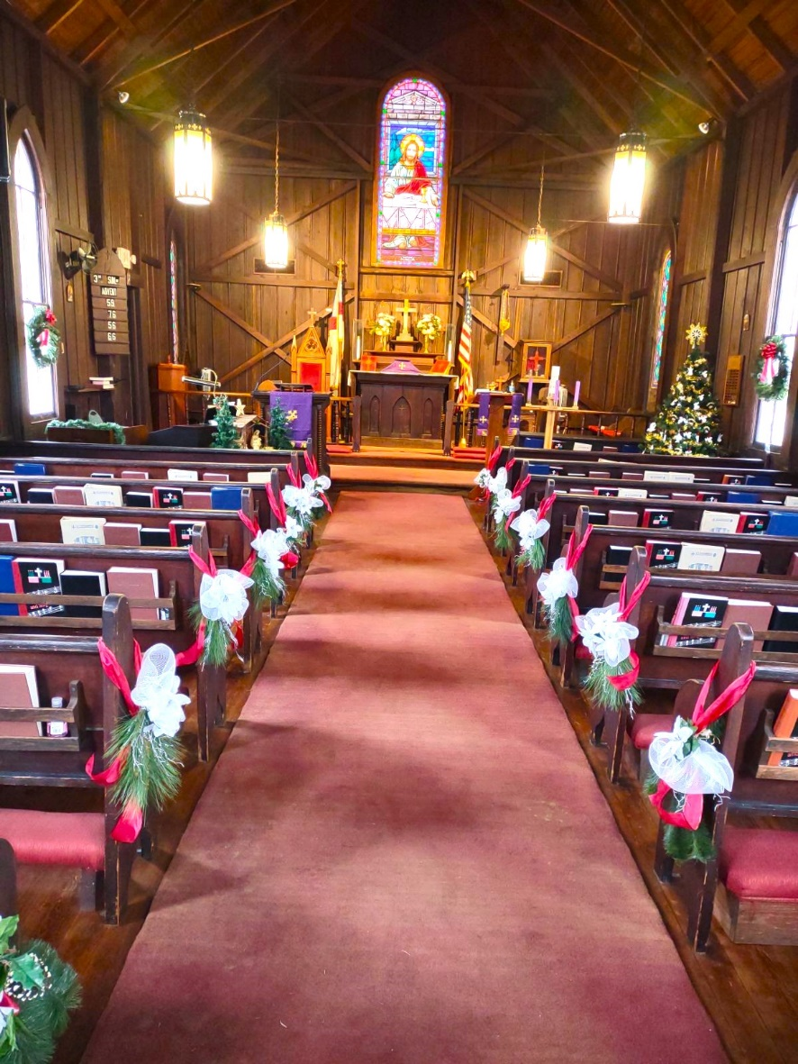

**\*+*+*+*+*+*+*+*+*+*+*+*+*+*+*+*+*+*+*+*+*+*+*+*+*+*+*+*+*+*+*+*+*+*+*+*+*+*+*+*+*+*+*+*+*+*+*+\***

## “ Whoever serves me must follow me; and where I am, my servant also will be. My Father will honor the one who serves me.” [John 12:26](https://www.biblestudytools.com/john/12-26.html)

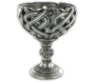**Chalice Bearers Lay Readers MC900391134[1]**

**January January**

**1/7 - Alex Matisco 1/7 – Debra Wright**

**1/14 – Stephanie Hencin 1/14 – Sam Tift**

**1/21 – Annette Jones 1/21 – Alex Matisco**

**1/28 – Neil Boyle 1/28 – Cherie Harris**

**\*+*+*+*+*+*+*+*+*+*+*+*+*+*+*+*+*+*+*+*+*+*+*+*+*+*+*+*+*+*+*+*+*+*+*+*+*+*+*+*+*+*+*+*+*+*+*+\***

**MC900384256[1] Sunday School Teaching Schedule for January MC900384256[1]**

Jan 7th: Pete & Jane Jan 14th: Stephanie & Becky

Jan 21st:  Diane & Diana Jan 28th: Diane & Becky

**+*+*+*+*+*+*+*+*+*+*+*+*+*+*+*+*+*+*+*+*+*+*+*+*+*+*+*+*+*+*+*+*+*+*+*+*+*+*+*+\***

**"For I was hungry and you gave me food, I was thirsty and you gave me drink, I was a stranger and you welcomed me, I was naked and you clothed me, I was sick and you visited me, I was in prison and you came to me. Truly I tell you, whatever you did for one of the least of these brothers and sisters of mine, you did for me."** [*Matthew 25:35-40*](https://www.biblestudytools.com/matthew/passage/?q=matthew+25:35-40)

**+*+*+*+*+*+*+*+*+*+*+*+*+*+*+*+*+*+*+*+*+*+*+*+*+*+*+*+*+*+*+*+*+*+*+*+*+*+*+*+\***

**A VERY HAPPY NEW YEAR TO EACH OF YOU!**

***From your Editor***