  BartholoMewsings 
St. Bartholomew’s Episcopal Church, P.O. Box 906, High Springs, Fl 32655
http://www.stbartshighsprings.org/ www.facebook.com/stbartshighsprings

May 2021 Vol. XII Issue 5
--------Vicar’s Message-------

May the grace, peace, and love of our Lord Jesus Christ be with you.

We have been experiencing a great and wonderful Easter Season in the family of St. Bart’s. Our Easter service attendance was one of the best we have had at our church. I was doubtful because of the COVID fear that still exists but what a surprise and wonderful gift was given to me on Easter. I hope it was the same for you. We are all called by our faithful God to worship in community and I’ve greatly missed what we had before COVID. Absence does make the heart grow fonder according to several studies. The studies show that this particularly applies to intimacy. There is a Divine message in all things and I can’t help but look at COVID in any other way than a Divine message.
What comes to my mind is forgetting that we can do nothing without God’s presence. The Biblical question is do we live our lives with or without God? (With me or without me?) Any reader of Scripture comes to know that God is a very personal God particularly when it comes to his intimate attachment to his children. Yes, he disciplines with a teaching purpose in mind but he always forgives those who learn the lesson in repentance because of his great love for us. Without God we definitely walk in the valley of the shadow of death all alone. The Easter Season brings God’s love ever so close to our lives as his very only Son, our Jesus, brings the hope of a great tomorrow and abundant life for those that are with him.
Although scaled back we had a very successful Pioneer Day event. The onions were sold out and the tours in the Sanctuary shared our faith’s presence in the development of High Springs over the years. Our 125th celebration is well into the planning phase and I invite the members to contact Jane or Ruthann to be part of this event. We are getting outside community support that makes my heart jump for joy as our God brings his Divine message to High Springs through us. This is a great opportunity to show your faith and that a life with God is never boring. I know.
Pentecost will come at the end of this month and that brings an even greater gift from our loving God. Stay tuned and come to church.
Much love to all, fr lance+

Editor’s Note
. We hope you are enjoying the Newsletter and we welcome your comments and suggestions.
Deadline for next issue is May 23rd.
Contact: Annette Jones - (386) 454-8585 pgrscoot97@aol.com


May is a beautiful time of the year—flowers and trees are blooming, and the weather is pleasant. It is also the month when we celebrate our Mothers. With that in mind your editor has inserted snippets about Mothers.

And Adam called his wife’s name Eve; because she was the mother of all living. ~ Genesis 3:20
^^^^^^^^^^^^^^^^^^^^^^^^^^^^^^^^^^^^^^^^^^^^^^^^^^^^^^^^^^^^^^^^^^^^^^^^^^^^^^^^^^^^^^^^^^^^^^^^^^^^^^^^^^^^^^^^^^^^^


Greetings From the Senior Warden……Carol Griffin 386-497-2292

I continue to be grateful for our St. Bart’s family. I see many examples of our love for each other and our church throughout the entire congregation. Maybe Spring is in the air and we are rejuvenated, but it seems more and more people are getting involved in the church activities. We have a vibrant (and growing) DOK, continuing work is being done on our Memorial Garden and 125th Anniversary Celebration. There is also the work behind the scenes that always gets done as if by magic; setting-up the Parrish Hall so we can resume a Coffee Hour, cleaning both buildings, weeding the planting area in front of the Parrish Hall, mowing the property, preparing our Newsletter, preparing and leading meetings, creating and sending cards to members and others in our community, volunteering for Pioneer Day Weekend, picking up flowers, the routine work of running the church and where would we be without Fr. Lance’s dedication, guidance and love.
Additionally, I see the love and concern that is given to those in need within our church and the community. We reach out to those that are alone, those that are ill, their caretakers and offer prayers daily for our church. The food pantry is a small way to contribute for those in need in the community as well as St. Bart’s. Please remember to bring your food donations to church on Sundays and place them in the basket in the back of the church.

Just before heading to the computer to send this off to Annette, I read the following:
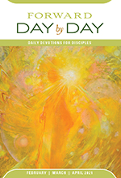
TUESDAY, April 20: “We love one another not to get on God’s good side but in thanksgiving for God’s gracious love for us. Let us be signs of love for others, for God has loved us first.”
It seemed to sum-up my thoughts (a Godwink?). I want to encourage you to read this publication on a daily basis. It has been generously donated by a church-member for many years and is a good way to start your day.
Continue to walk in God’s love and Thank you all…..
“Bear one another’s burdens, and in this way you will fulfill the law of Christ.” Galatians 6:2 (NRSV)
“Do nothing from selfish ambition or conceit, but in humility regard others as better than yourselves.” Philippians 2:3 (NRSV)
“Beloved, since God loved us so much, we also ought to love one another. ¹² No one has ever seen God; if we love one another, God lives in us, and his love is perfected in us.” 1 John 4:11-12 (NRSV)

Some Reminders:
- We are still trying to get update the records for the church; the forms are in the Parrish Hall. Please take the time to complete these for us. If you need to get your membership changed to St. Bart’s, please contact me and we will get that done.
- If you would like to get confirmed or received in the Episcopal Church, please see Fr. Lance, or contact one of our Mission Board Members. With Bishop Howard coming to our 125th Anniversary, this is the ideal time to make this commitment.
******************************************************************************************************
To be a mother is by no means second class. Men may have the authority in the home, but the women have the influence. The mother, more than the father, is the one who molds and shapes those little lives from day one. ~ John MacArthur
John 19:25-27
25 Near the cross of Jesus stood his mother, his mother’s sister, Mary the wife of Clopas, and Mary Magdalene. 26 When Jesus saw his mother there, and the disciple whom he loved standing nearby, he said to her, “Woman, here is your son,” 27 and to the disciple, “Here is your mother.” From that time on, this disciple took her into his home.

******************************************************************************************************
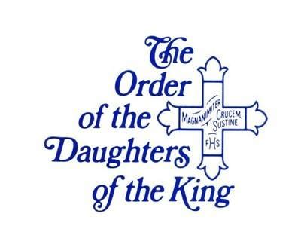
Greetings from St Bart’s Daughters of the King!

Our April meeting was once again inspiring and uplifting. Beth, as usual, did a great job guiding new and existing members
through our study guide. All are looking forward to the installation of our new Sisters in June!
We have a lot of projects in the works for both our church and the community. We are planning a DOK wall in the Parrish Hall, making gift bags for visitors and working on other projects for our church. Our food pantry is a blessing to those in need, so one new project is a FOOD BASKET to be placed at the entrance to the Sanctuary to collect canned and boxed food donations each Sunday. Please donate as you can. Also during Pioneer Days, April 24-25, we will be manning the Sanctuary in order for people to view our beautiful church and learn it’s history. Stop by and say “Hi”!
Our next meeting is scheduled for Saturday, May,1st at 9:30.
LADIES! Please feel free to attend and EXPECT to be inspired.
For His Sake,
Peggy Addington, President

******************************************************************************************************
What a mother sings to the cradle goes all the way down to the coffin.
~ Henry Ward Beecher

Proverbs 31:27-30 She looketh well to the ways of her household, and eateth not the bread of idleness. Her children arise up, and call her blessed; her husband also, and he praiseth her. Many daughters have done virtuously, but thou excellest them all. Favor is deceitful, and beauty is vain: but a woman that feareth the Lord, she shall be praised.
******************************************************************************************************


Birthdays Anniversaries 

May 3 – Ella Hansen 13 – Lee Forzly May 22 – Diane & Mike Shimek
6 – George Forzly 14 – Gayle Schiller
10 – Beth Horne 16 – Dominic Scianimanico
10 – Michelle Palmer 16 – Stephen R Lewis
10 – Mike Shimek 20 – Nell Johnston
11 – Alyssa Moomaw 20 – Beth Treese
11 – Pete Woodward 21 – Patrick Treese
12 – Sharon Scianimanico 28 – Jena Brodhead
13 – Rosina Dennis

Congratulations to Each of YOU! If your name does not appear here, please contact your editor to have it added for next time

It’s Official – Let the Fun Begin!!!!!

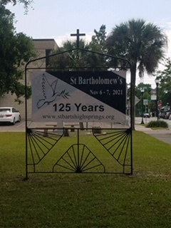

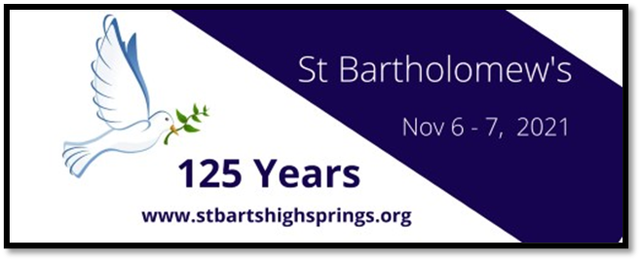

This year 2021 St. Bartholomew’s Episcopal church will be 125 years old.
November 6th & 7th 2021 we will be celebrating St. Bartholomew’s 125th birthday.
We will be announcing updates to this glorious occasion.
Your support and ideas are greatly appreciated. Contacts: Ruthann Swanson or Jane Woodward.

Another reflection found from the past was written by Jim Young, husband of Estelle Pope Young, Deacon-in-Residence, in 1996 for St. Bartholomew’s 100th Anniversary.

STICKING IT OUT
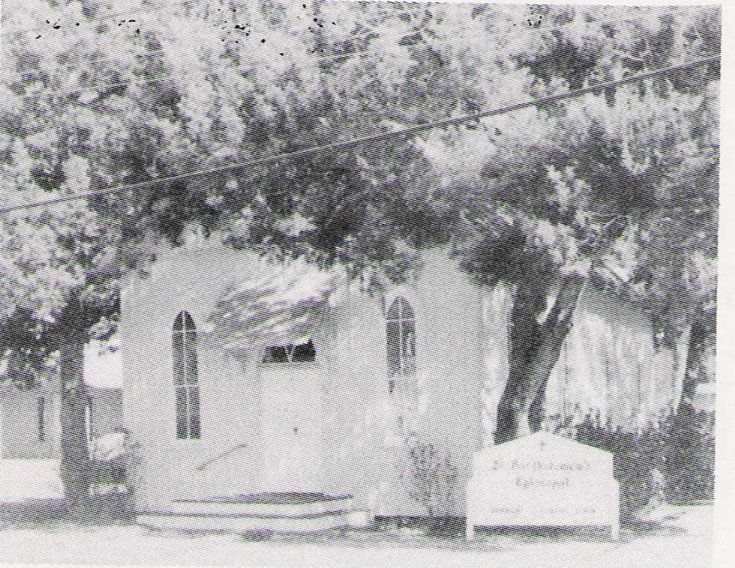
Insurance claims deem hurricanes
are Acts of God which starts the train
of actions in this history.
This church has stood a century.

It took an Act of God to get us started
and God has kept us going ever since.

The hurricane knocked down some trees.
We got them free – it was a breeze!
God gave the lumber, men their sweat
So that this church is with us yet.

It took an Act of God to get us started
and God has kept us going ever since.

The railroads left and people too
with folks remaining very few.
Numbers went down and funds were slim
but some stayed on with hopes undimmed.

It took an Act of God to get us started
And God has kept us going ever since. Old drawing of St Bartholomew’s Church

******************************************************************************************************  Lessons for May 
May 2nd : Acts 8:26-40; Psalm 22:24-30; 1 John 4:7-21; John 15:1-8
9th: Acts 10:44-48; Psalm 98; 1 John 5:1-6; John 15:9-17
16th: Acts 1:15-17, 21-26; Psalm 1; 1 John 5:9-13; John 17:6-19
23rd: Day of Pentecost Acts 2:1-21; Psalm 104:25-35, 37; Romans 8:22-27;
John 15:26-27,16:4b-15
30th: Trinity Sunday Isaiah 6:1-8; Psalm 29; Romans 8:12-17; John 3:1-17

Your mother’s voice is the first voice you ever hear – even before you are born. Even as a newborn baby, you know your Mother and prefer her above anyone else. Cherish your mother and be sure she knows you appreciate everything she does for you. The days are short, love your mother before time is gone. If your mother has already gone on before you, take some time to recall memories of her. Share these memories with your family so that she will live on in your hearts.

******************************************************************************************************
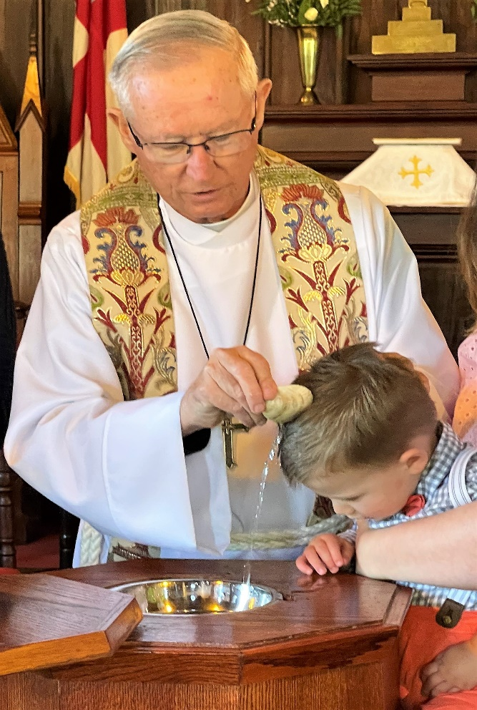
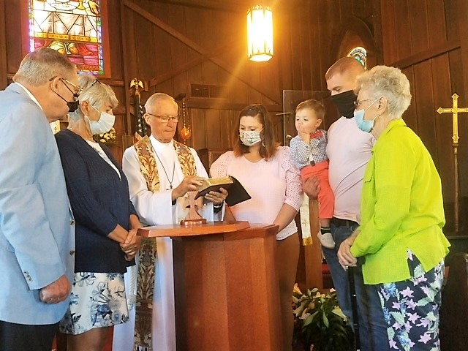

Oliver Ellison’s Baptism on Easter
was a Special
Day at St. Bart’s.

Pioneer Days 2021

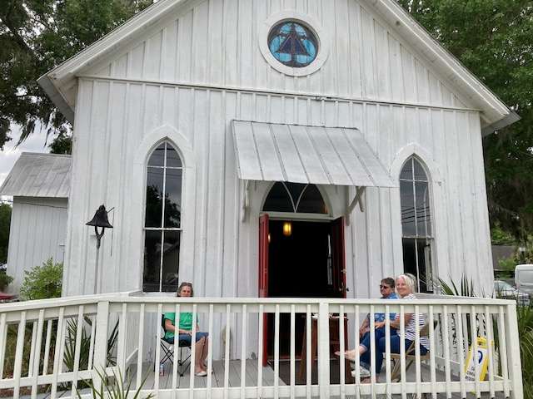
Once again, the Vidalia Onion Sales was a
great success

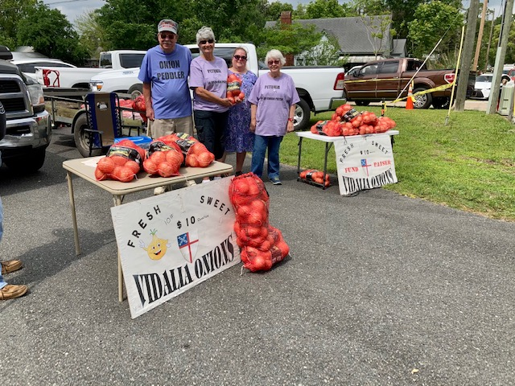

!

Our Vidalia Onion Sales was again a great success !

Ladies of the church gave tours of our
historic building.

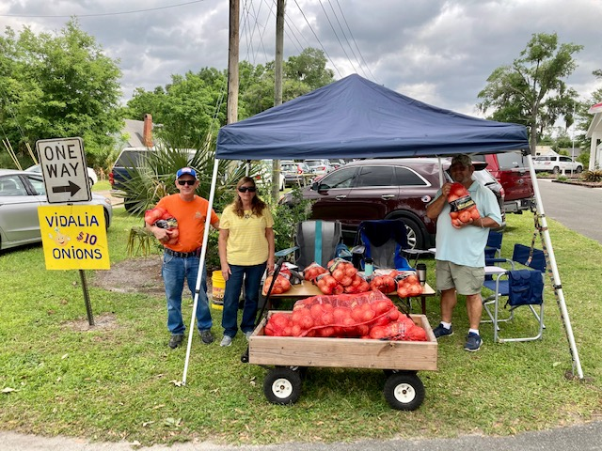

The Parking Crew sold onions too

 Angels Without Wings

Our church is made up of a loving, caring “family.” This was especially evident the last weekend in April at High Springs Pioneer Days when our “family” worked together to promote St. Bartholomew’s Church, and earn money needed to provide upcoming projects. All the while they were working together they were enjoying each others’ company and growing stronger bonds. God’s people were at work!
Our Angels without Wings for May are….All those who helped in any way at Pioneer Days.

The impression that a praying mother leaves upon her children is lifelong. Perhaps when you are dead and gone your prayer will be answered. ~ D.L. Moody

Proverbs 31:10 -12
10 A wife of noble character who can find? She is worth far more than rubies. 11 Her husband has full confidence in her and lacks nothing of value. 12 She brings him good, not harm, all the days of her life.

******************************************************************************************************

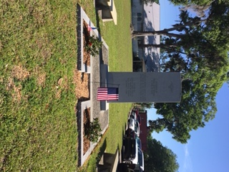

Many Thanks to High Springs Garden Club for
sprucing up our Veterans’ Memorial.

They exemplify Matthew 6:21 NRSV – “For where your treasure is, there your heart will be also”. St. Bartholomew’s and High Springs appreciate and will enjoy their gift to the
community.

